
Luminous™ – Movable Glass Walls by Kwik-Wall
Technical Data
STELLA · NOVA · LUNA · ILLONA · AVA · MATA
NOVA™ – Individual, Pivoting Panels
SECTION 10 22 39 – FOLDING PANEL PARTITIONS – GLASS

Overview  Panel Type  √ Individual Hinged-Paired  Continuously-Hinged |  | 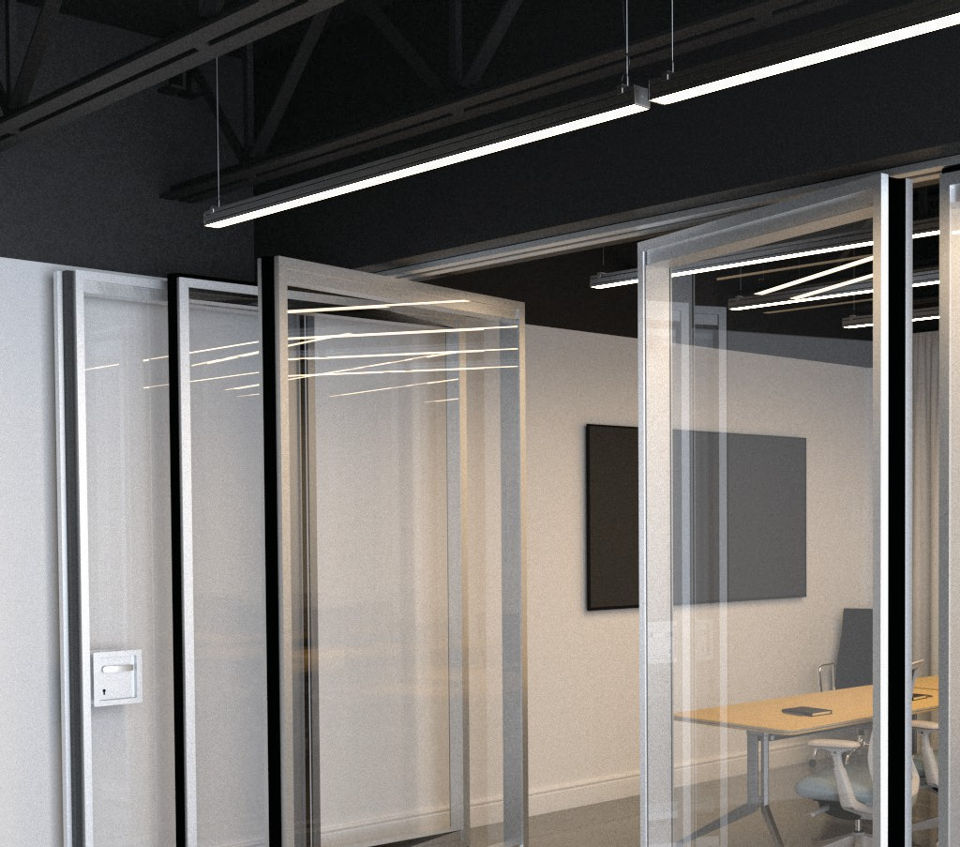  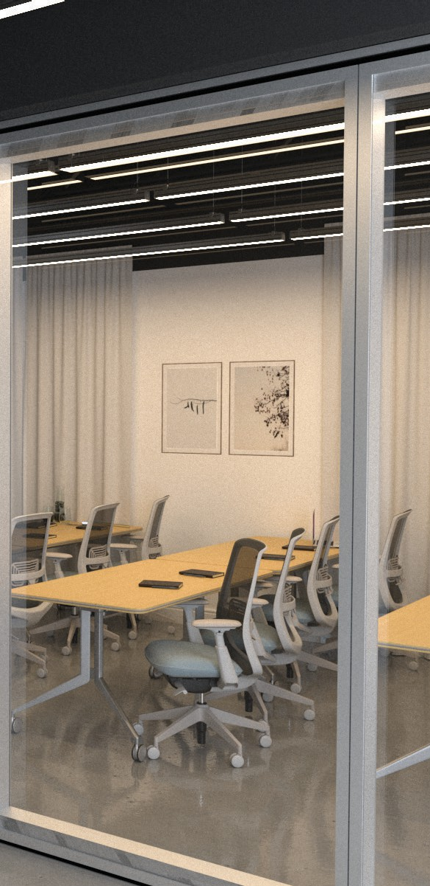  Luminous NOVA – the Industry’s premium performing, high STC framed glass wall, provides 44 STC sound control in manually operated, multi-directional, pivoting, individual panels that store on centerline at room perimeters. Fully framed panels eliminate the need for back-painted glass as the glass is fully contained inside NOVA’s 4-11/16” (44 STC) frame. Pass doors with full ADA-compliant panic hardware can be located in any panel.
Partition Support
√ Top Support Floor Support
Stacking Conf igurations
√ Centerline Offset Remote
√ Bi-Parting
Frame Thickness
4-11/16” [119] | 50 STC
√ 4-9/16” [116] | 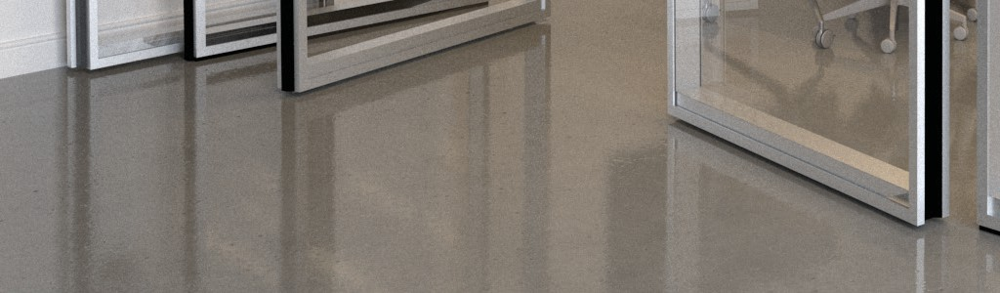  44 STC
2-13/16” [71]
1-3/4” [44]
1-3/8” [35]
Frameless
Operation – Panels
Fully-Automatic
√ Manual
Operation – Seals  Automatic  √ Manual Fixed |  | WEIGHTS:
Sound Control  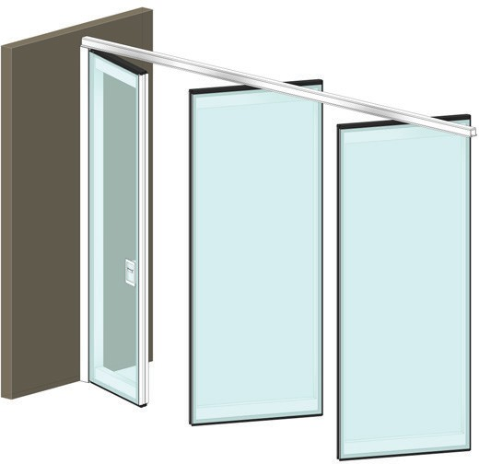  50 STC  √ 44 STC  43 STC  35 STC  33 STC  Non-Acoustic |  | WEIGHTS:
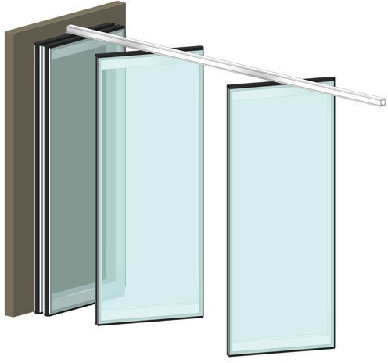

8.0 lbs. / sq. ft. [39kg / m2]
Power Requirement  Yes – Fully-Automatic  Yes – Auto-Seals or Blinds  √ No – Manual |  | NOVA
 |  | More Information

NOVA™ – Individual, Pivoting Panels
SECTION 10 22 39 – FOLDING PANEL PARTITIONS – GLASS

PART 1 - GENERAL

DESCRIPTION
- General
  - Furnish and install acoustically rated, movable glass par-titions, and suspension system with electrically or man-ually operated seal systems. Provide all labor, materials, tools, equipment, and services for glass movable walls in accordance with provisions of contract documents.

RELATED WORK BY OTHERS
    - Preparation of opening will be by General Contractor. Any de-viation of site conditions contrary to approved shop drawings must be called to the attention of the architect.
    - All header, blocking, support structures, jambs, and track en-closures, as required in

1.04 Quality Assurance.
    - Pre-punching of support structure in accordance with ap-proved shop drawings.
    - Paint or otherwise finishing all trim and other materials adjoin-ing head and jamb of the partitions.

SUBMITTALS
    - Complete shop drawings are to be provided prior to fabrication indicating construction and installation details. Shop draw-ings must be submitted within 60 days after receipt of signed contract. Show performance test results and details of con-struction materials, colors, profiles, and opening dimensions. Appropriate LEED 2009 (v3) credit for the following:
IEQ Credit 8.1: Daylight & Views – Daylight 75% of Spaces IEQ Credit 8.2: Daylight & Views – Daylight 90% of Spaces

QUALITY ASSURANCE
    - Preparation of the opening shall conform to the criteria set forth per ASTM E557 Standard Practice for Architectural Appli-cation and Installation of Operable Partitions.
    - Glass shall be safety glass per ISO 28278-1:2011 or ASTM C1048-18 equivalent standard
    - Partition shall be tested to the ISO 10140-2 or ASTM E90 equiv-alent standard
    - Product to meet ANSI/ASA Standard S12.60, Acoustical Per-formance Criteria, Design Requirement and Guidelines for Schools.

PRODUCT DELIVERY, STORAGE, AND HANDLING
    - Proper storage of partitions before installation and continued protection during and after installation will be the responsibili-ty of the General Contractor.

MANUFACTURER WARRANTY
    - Provide folding glass partitions system’s standard limited war-ranty guaranteed against defects in material and workmanship for a period of five (5) years for panels and 10 years for tracks. Warranty does not cover glass damage after delivery, abuse or misuse, and must be installed by a factory trained, approved installer.

PART 2 - PRODUCTS

ACCEPTABLE MANUFACTURERS
    - Upon compliance with all the criteria specified in this section, Manufacturers wishing to bid products similar to the product specified must submit to the architect 10 days prior to bidding complete data in support of compliance and a list of three past installations of products similar to those listed. The submitting manufacturer guarantees the proposed substituted product complies with the product specified and as detailed on the drawings.

MATERIALS
    - Product to be top supported, individual, centerline operat-ing acoustically rated glass panels, with Basis-of-Design the NOVA™ series by Kwik-Wall.
    - Panel Construction
      - Panels shall be nominally 4 9/16 [116] thick and up to 51 1/8” [1300] in width.
      - Frames shall be of architectural grade aluminum with powder coated or anodized finish with vertical edges that form a male and female style interlocking connec-tion. Standard panel heights up to 10’-0” [3098] with full glass fronts.
        - Optional heights up to 14’-9” [4500] using horizon-tal mullions and dual stacked glass
      - Glazing sealants and gaskets suited and shaped for the glass configuration and thickness.
      - Horizontal Seals
- Manually operated
  - Top and bottom horizontal manually operated, crank activated seals shall provide continuous contact with the track and floor with a total clearance of 3/4” [20] when extended and provide a minimum 40lbs [18kg] of seal forces. Each top and bottom seal has an operating range of 3/4” [20].
- Top and bottom PVC vinyl seal shoes to form tight acoustic connections with track and floors.
      - Vertical Seals: Vertical sound seals shall be of male/fe-male configuration with full length gaskets, ensure pan-el- to-panel alignment and prevent sound leaks between panels.

NOVA™ – Individual, Pivoting Panels
SECTION 10 22 39 – FOLDING PANEL PARTITIONS – GLASS

      - Glass: The glass shall be factory installed low iron, clear tempered on both sides of the panels with a minimum 3 1/2” [89] airspace between the glass. Either laminated or tempered safety glass can be supplied to meet the safety and acoustical performance requirements in Section 1.04.
        - Glass thickness to be nominally 1/4” [6] and with final overall panel thickness of nominally 4 9/16” [116].
        - Options:
          - Glass can be fully back-painted or custom to create opaque writing surfaces
          - Glass can be customized with decals and etch-ing (requires factory pre-approval)
      - Weight of Panels: 8.0 lbs./sq. ft. [39 kg/m2]
    - Suspension system. Track shall be of clear anod-ized, black or white powder coated architectural grade extruded aluminum alloy 6063-T6. Track design shall provide integral support for adjoining ceiling, soffit, or plenum sound barrier. Track shall be connected to the structural support by pairs of threaded steel hanger rods. Built-in ceiling trim shall match finish, providing enclosure of plenum sound barrier on both sides of the track for maxi-mum sound control. A section of track will be re-movable in order to make it possible for a panel to be removed from the track for later maintenance.
  - Each panel shall be supported by one 4-wheeled carriers.
  - Plenum closure (by others): Design of plenum closure must permit lifting out of header panels to adjust track height. Plenum closure required for optimum sound control of partition per ASTM E-557.
    - Finishes
      - Panel frames shall be clear anodized, black or white (add-ed cost) powder coated aluminum
        - Optional (upcharge):
          - Customer selected custom RAL color (requires factory pre-approval and may extend lead time)
      - Fixed, continuous gasketing and sound seals gaskets shall be black.
      - Optional solid faced panels to be of same frame con-struction and match the profiles of adjacent panels. These solid faced panels in lieu of glass shall be of (select one):
        - Manufacturer’s standard selection of melamine laminated to medium density fiberboard (MDF).
        - High pressure laminate (HPL) from manufactur-er’s standard selection laminated to MDF.
        - Manufacturer’s standard writable and magnetic high-pressure laminate with MDF.
    - Available Accessories/Options
      - Inset pass door, single “U” shaped pass door, ADA com-pliant, allows the pass door to be located in any location in the opening. Pass door includes a turn handle on both sides and solid back-painted glass above door.
        - Panic hardware with lock override available.
      - Inset pass door, double “L” shaped pass door, ADA com-pliant, allows the pass doors to be located in any location in the opening. Pass doors include a turn handle on both sides and solid back-painted glass above doors.
        - Panic hardware with lock override available on one of the doors.
      - Full height pass door attached to carrier panel
      - Full height pass door attached to wall jamb
      - Locks
      - Fully or partially back-painted glass
      - Internal muntins

OPERATION
    - Panels shall be manually moved from the storage area, posi-tioned in the opening, and the seals set.
      - Manually operated
        - Seals manually set and retract by means of crank operation at edge of panel.
    - Final partition closure to be by (select one):
      - Expandable panel with integral telescopic jamb which compensates for minor wall irregularities and provides seal force against the adjacent wall for optimum sound control.
        - Manually operated. Solid face only.
          - The jamb will manually extend by means of crank operation on face of panel. The jamb shall extend a maximum of 4” [102].
      - Hinged closure panel. Full height hinged panel at one end of the opening that is hinged to a fixed two-piece adjustable aluminum jamb and is permanently attached in the opening.
      - Manually operated
        - Move panels into place
        - Manually set seals via crank operation from edge of panel
        - Set closure mechanism (crank operation or hinge panel closure)
        - Retract seals and manually move to storage area

NOVA™ – Individual, Pivoting Panels
SECTION 10 22 39 – FOLDING PANEL PARTITIONS – GLASS

ACOUSTICAL PERFORMANCE
    - Supply a copy of the acoustical test report certifying that the partition was tested by an independent laboratory. The par-tition tested must be fully functional and meet ISO or ASTM standards. The test results must be similar to or exceed the performance specified. Any sound test not showing panel con-struction details and weight or not disclosing all of the informa-tion will not be valid. Manufacturers must also guarantee that the products proposed have the same characteristics as the products specified and are in accordance with the drawings.
    - Standard panel construction shall have obtained either an ISO dB or ASTM STC rating of (43 dB/44 STC.

PART 3 - EXECUTION

3.01 EXECUTION
- Installation. The complete installation of the operable wall system shall be by an authorized factory-trained installer and be in strict accordance with the approved shop drawings and manufacturer’s standard printed specifications, instructions, and recommendations.
- Cleaning
  - All track and panel surfaces shall be wiped clean and free of handprints, grease, and soil.
  - Cartoning and other installation debris shall be removed to onsite waste collection area, provided by others.
- Training
  - Installer shall demonstrate proper operation and mainte-nance procedures to owner’s representative.
2, Operating handle and owner’s manuals shall be provided to owner’s representative.

NOVA™ – Individual, Pivoting Panels
SECTION 10 22 39 – FOLDING PANEL PARTITIONS – GLASS

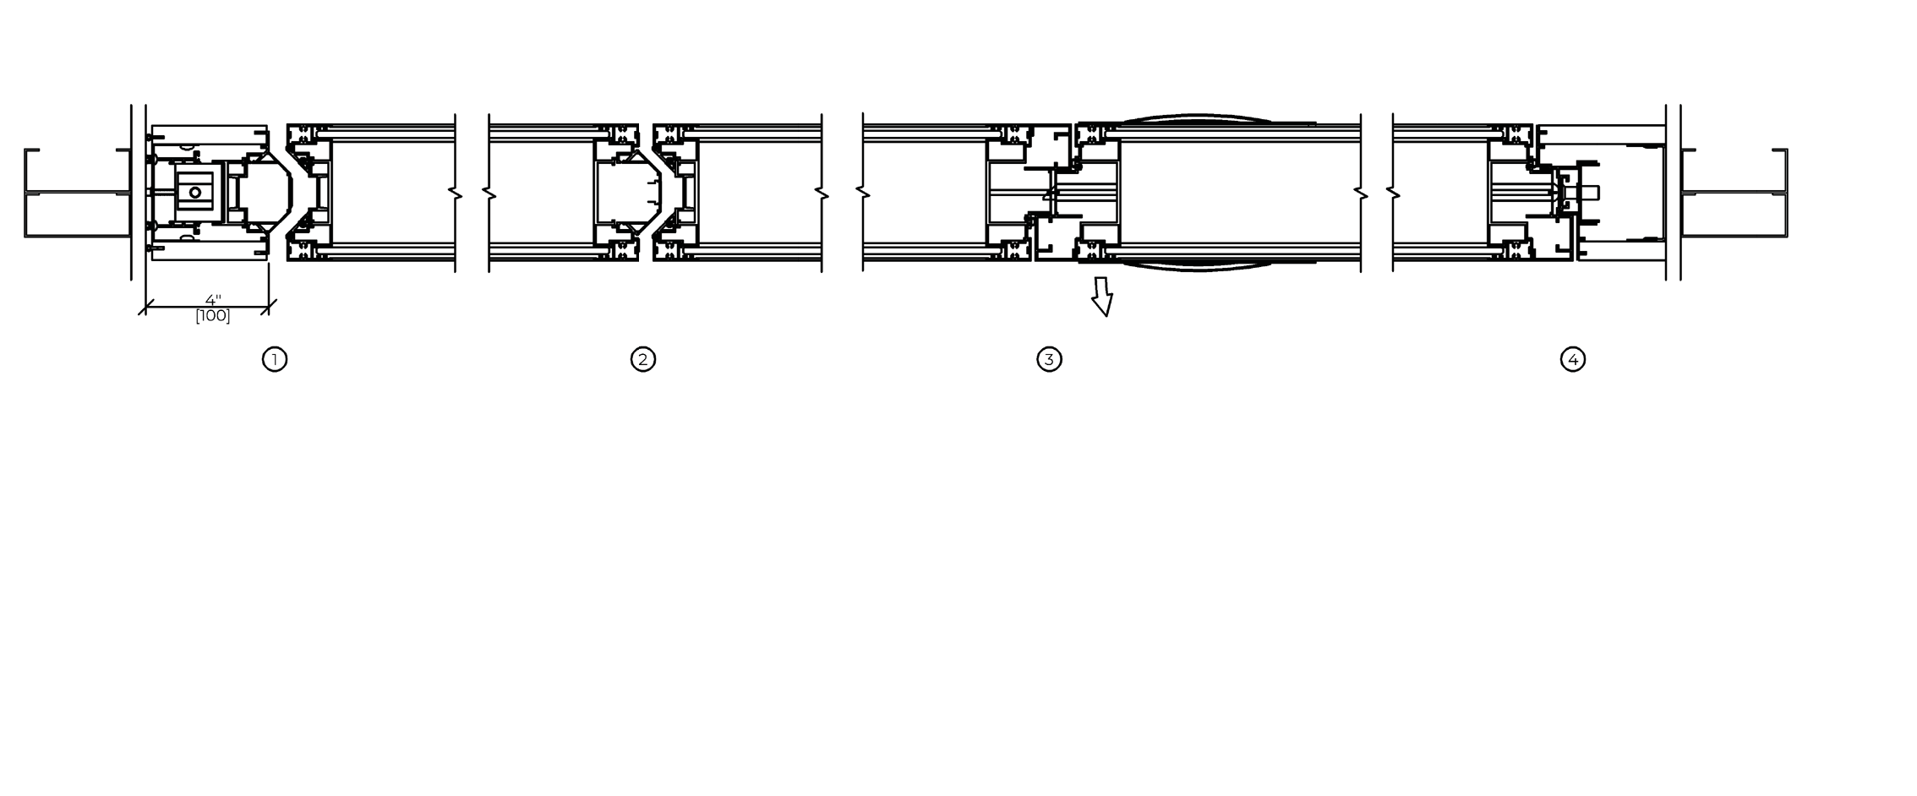
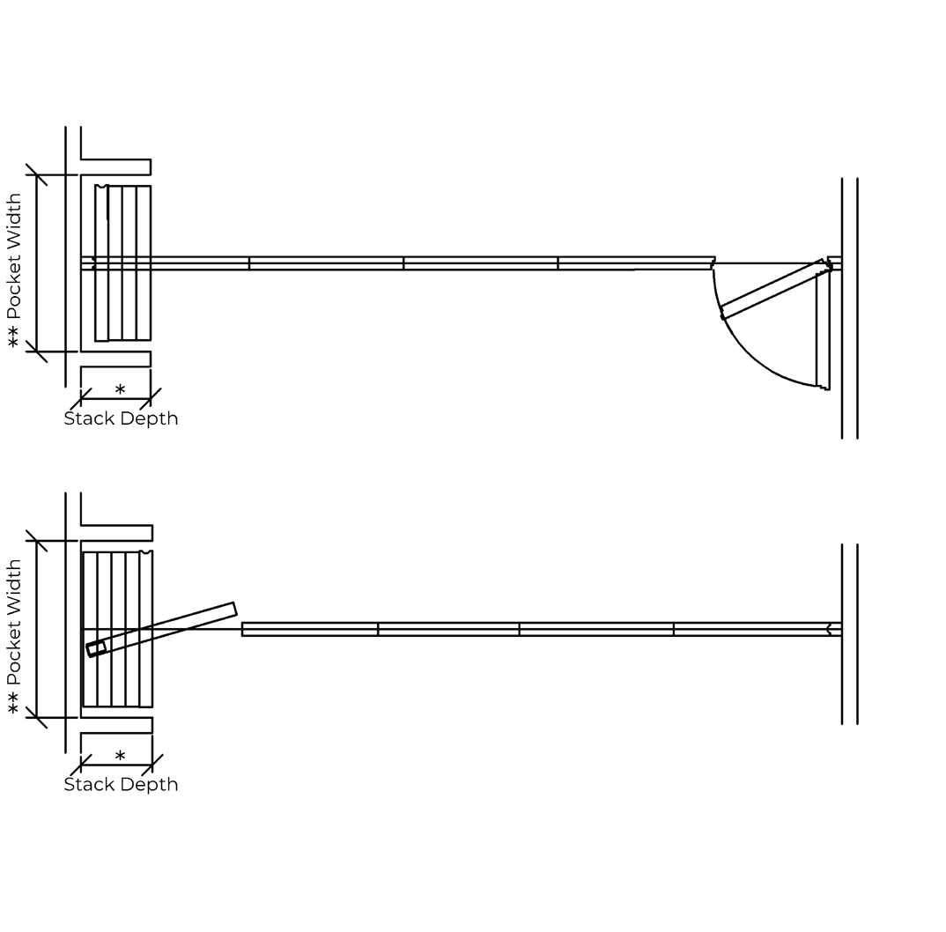
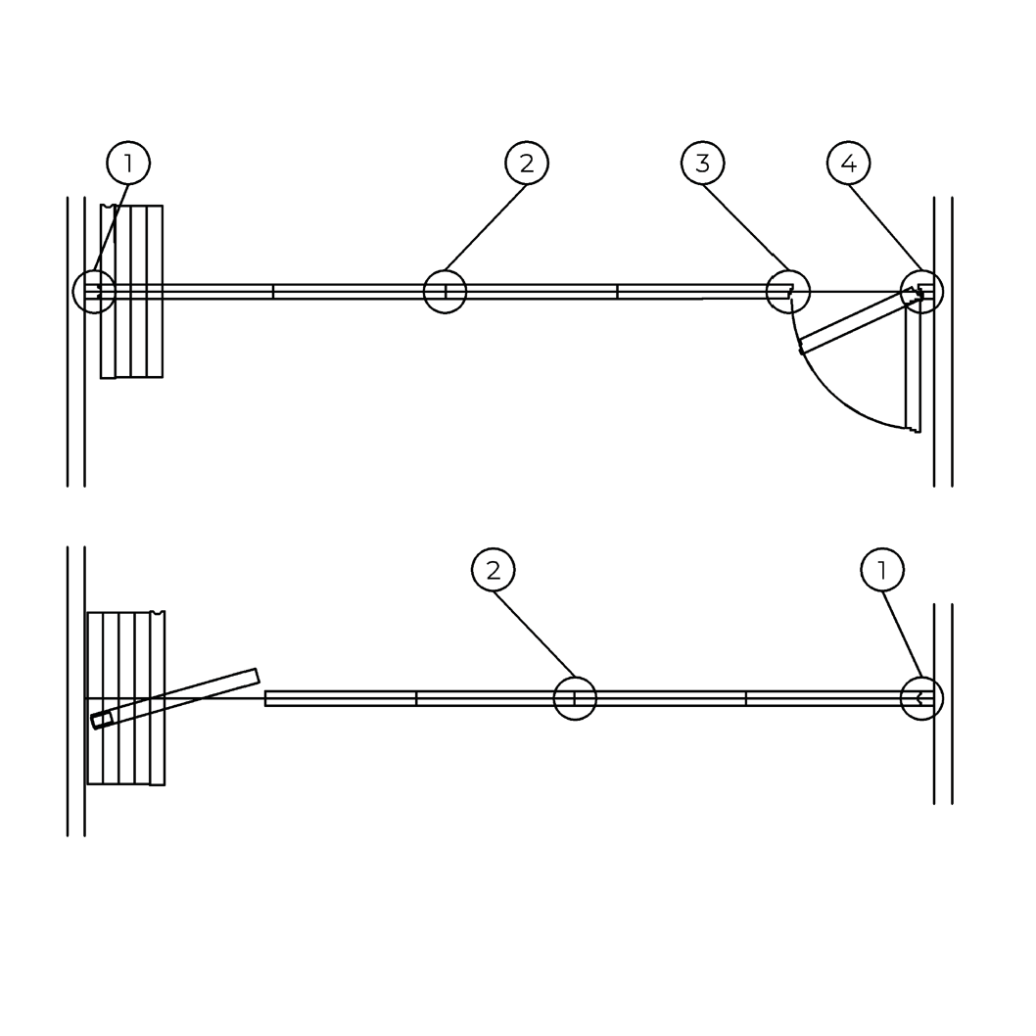
STACKING CONFIGURATIONS

HORIZONTAL DETAILS

Stack Depth Allowance: 5-1/8” [130] / panel*
*Add: 1-1/2” [38] glass jamb; 3.9” [100] for HPL jamb; 3-3/4” [95] for hinged jamb.
Pocket Width:
Widest panel + 3-1/2”ea. side of panel stack.

NOVA™ – Individual, Pivoting Panels
SECTION 10 22 39 – FOLDING PANEL PARTITIONS – GLASS

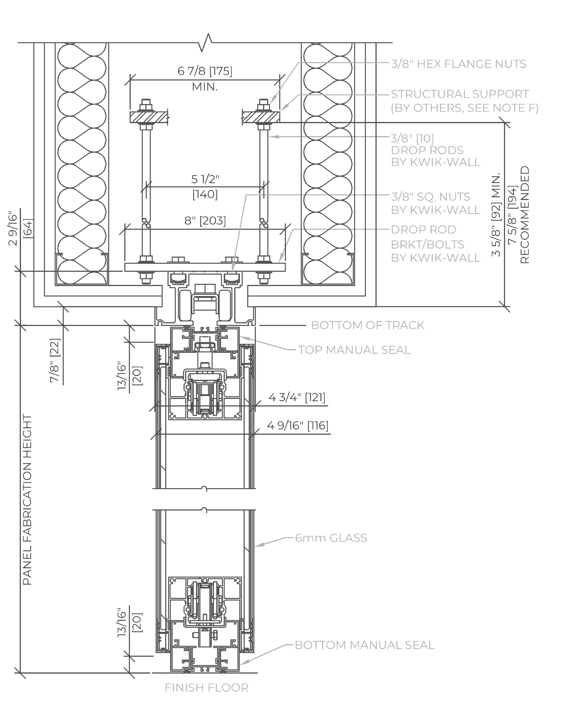
VERTICAL SECTIONS

NOVA™ – Individual, Pivoting Panels
SECTION 10 22 39 – FOLDING PANEL PARTITIONS – GLASS

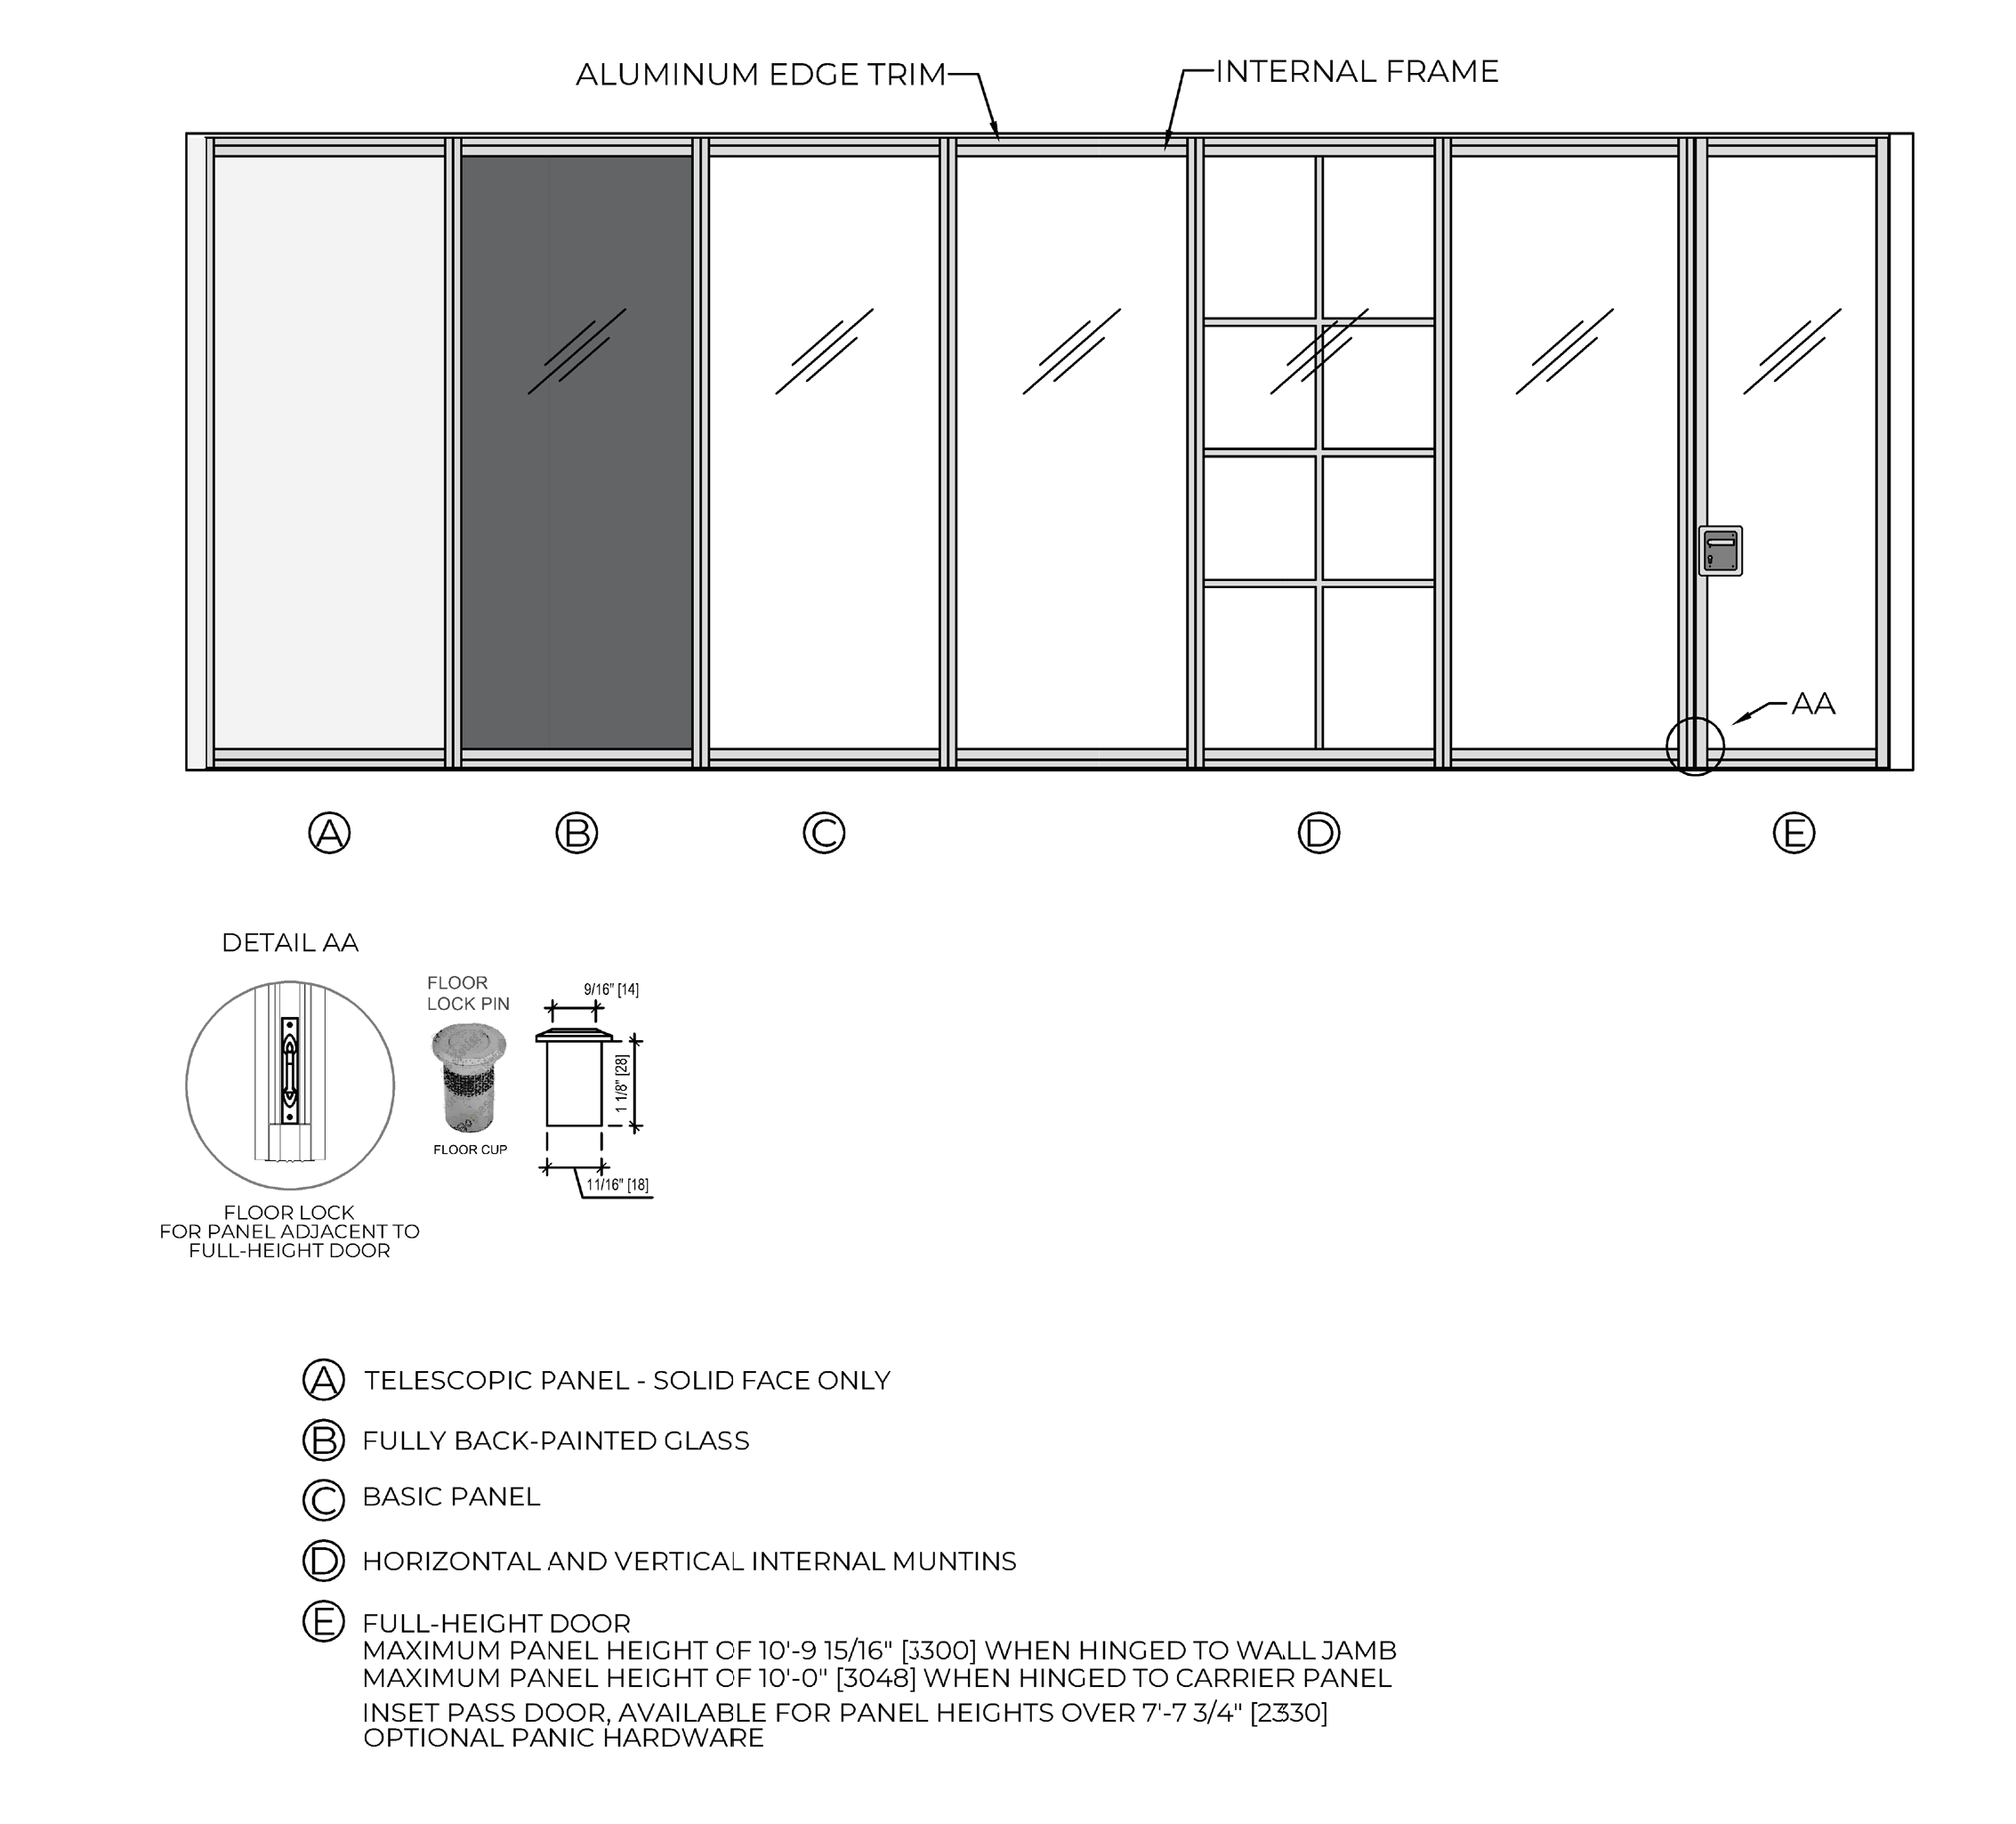
ELEVATION DETAILS

